Respiratory Illness Newsletter Templates
Use these templates to create articles for your tribal newsletter, newspaper, or magazine. Feel free to change the language and/or images to meet your needs!

Teaching Kids to Protect Our Community
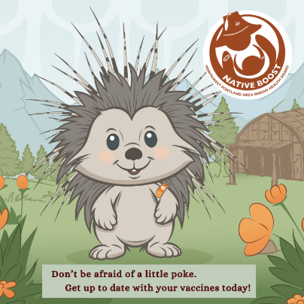
Respiratory illnesses - like whooping cough, pneumonia, flu, RSV, and COVID – can be extremely dangerous, or even deadly.

Fortunately, we have vaccines that can help! Vaccines teach our body’s warrior cells – or antibodies - how to recognize and fight certain serious diseases.

When kids are vaccinated against respiratory illnesses, it’s less likely that they will get sick. They are also less likely to spread illness to others who are more vulnerable - like Elders, babies too young to get vaccinated, and people with certain health conditions.

Who Should Get Vaccinated
Whooping Cough (DTaP Vaccine)  Pneumonia  RSV | Babies 2 mo., 4 mo., and 6 mo. AND Kids 15-18 mo.  and 4-6 years old  Babies 2 mo., 4 mo., and 6 mo. AND Kids 12-15 mo.  Babies < 8 mo. old AND Kids 8-19 mo. old
COVID & Flu | Everyone 6 mo. and older every year
Know that vaccines are safe. Serious reactions are rare. In fact, people are more likely to get hit by lightning than have a severe allergic reaction to any vaccine.

At your child’s next wellness appointment, talk with their health provider to learn what vaccines they need and when. Teaching our kids to be good relatives and protect our community is an important lesson to share.

For accurate childhood vaccine information that’s fact checked by trusted Elders and Native health professionals, visit Native Boost’s website at: www.IndianCountryECHO.org/Boost.

Do Kids Really Need a COVID Booster Every Year?

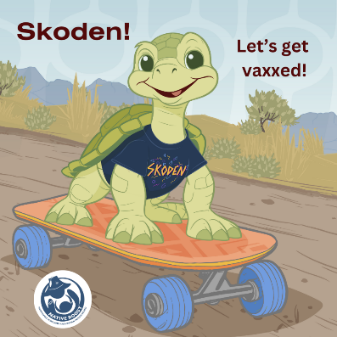
If you have a child, chances are you’ve wondered – Are the yearly COVID boosters really necessary? To help you decide, _____ [Native Boost or Your Clinic Name] put together this article.

First off, COVID is sneaky. To try to fool your body, the virus frequently changes how it looks. That’s why the vaccine is updated every year – so it can protect us from the most current versions of COVID.

As many of us know, COVID can be extremely dangerous for Elders and people with certain medical conditions, like asthma and diabetes. But something most people don’t know is that half the kids hospitalized with COVID last year had no underlying medical conditions.

The fact that so many healthy kids are ending up in the hospital should make all parents take pause, especially parents who are choosing not to vaccinate yearly because their kids are healthy or because they live a traditional lifestyle.

COVID is still a threat, and getting sick with the illness can have long-term impacts. 10-15% of children who get sick with COVID develop long-term symptoms – like fever, exhaustion, cough, muscle aches, and trouble breathing - that may last weeks, months, or even years.

Fortunately, we have the COVID vaccine. The yearly COVID booster’s strength is that it protects us from serious sickness. For example, kids who get the yearly COVID vaccine are about 90% less likely to get COVID. If your child gets sick, having vaccine protection means that their symptoms will likely be mild if they have any at all.

Plus, the COVID vaccine is safe. Part of the reason we know it’s safe is because it’s the most watched vaccine in history, and Tribes and Native people volunteered to help to test it. From this, we know serious reactions to the vaccine are extremely rare. In fact, people are more likely to get hit by lightning than have a severe allergic reaction to the COVID vaccine or any other vaccine.

Also, when your child gets the COVID vaccine, they are much less likely to get sick and spread illness to other people in your community – some of whom may be more vulnerable. That’s why COVID vaccines are recommended each year for everyone 6 months and older.

As parents, we have enough to worry about. Don’t have regrets. Keep your kids safe by getting them vaccinated against COVID each year.

For additional childhood vaccine information that’s fact checked by trusted Elders and Native health professionals, visit Native Boost’s website at: www.IndianCountryECHO.org/Boost.

Consider using these images to accompany your article:

