VacciNative Vaccines Series & Booster Shot Social Media Toolkit
Feel free to add your organization’s logo alongside the VacciNative logo on each social media post.

Post 1:
Sometimes we need multiple shots against a disease. Why? Each shot provides essential information your body needs to protect you. When you are protected, you also protect those you love. Learn more at: www.IndianCountryECHO.org/VacciNative

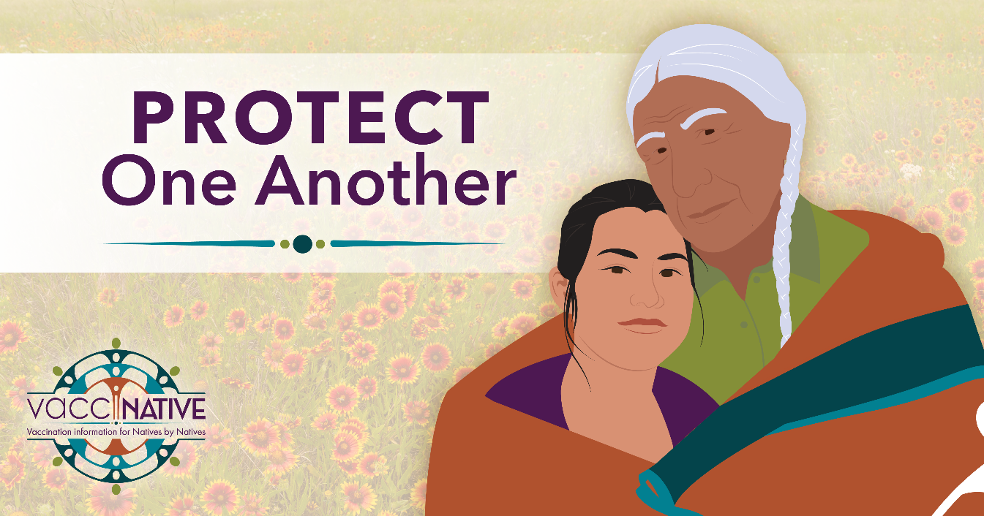
Facebook
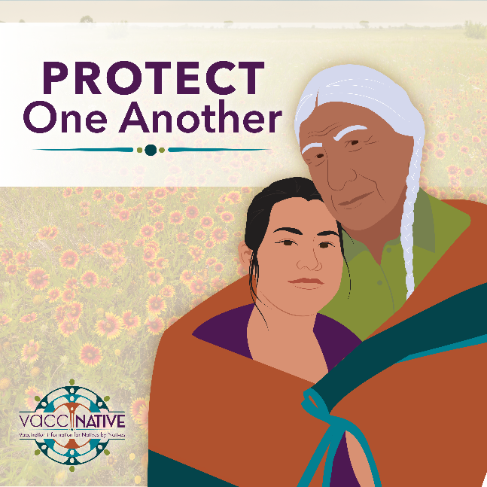
Instagram
Post 2:
Over time diseases can change. Booster shots carry the most up-to-date instructions your body needs to be able to fight the most current version(s) of a disease. Get boosted to protect yourself, your family, and your community. Learn more at: www.IndianCountryECHO.org/VacciNative

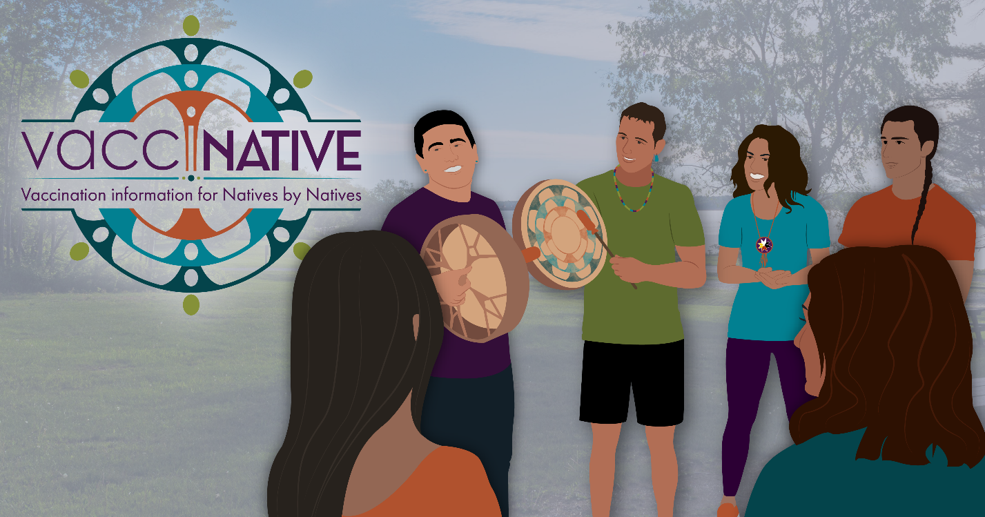
Facebook
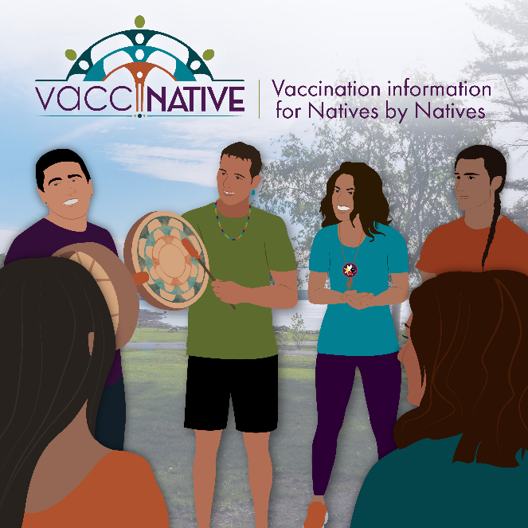
Instagram
Post 3:
As Native people, our communities have worked hard to protect each member, including our most vulnerable. Getting vaccinated and boosted protects you and your community. For accurate vaccination info for Native people by Native people, visit: www.IndianCountryECHO.org/VacciNative
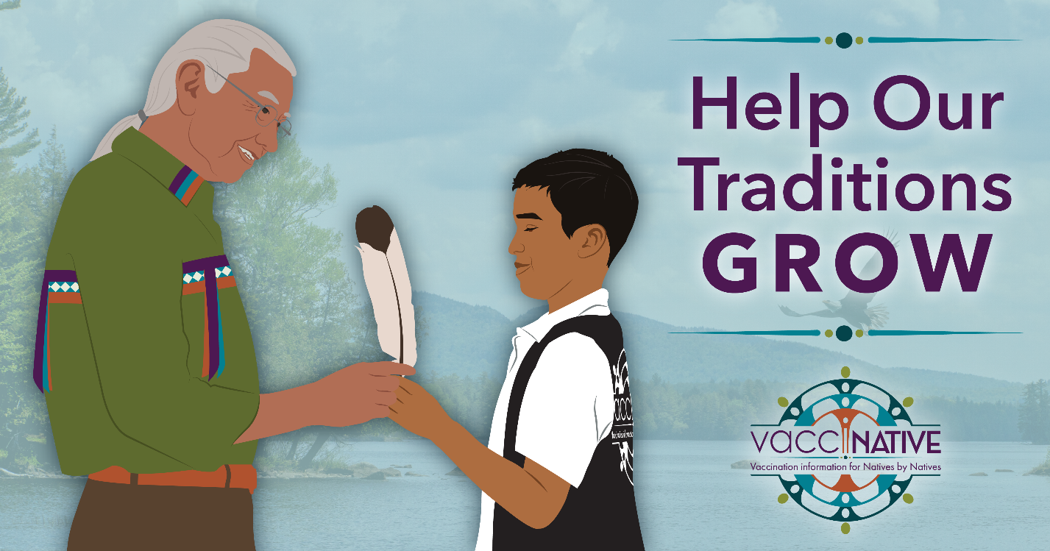
Facebook
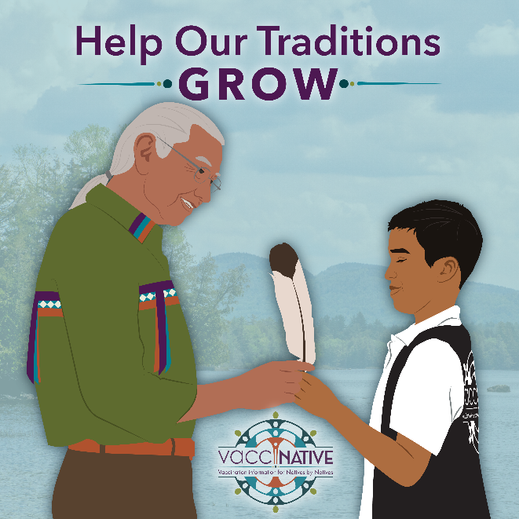
Instagram
Post 4:
When we get vaccinated, it’s less likely that we will get sick. It’s also less likely that we make others sick. Protect your community by asking your provider if you’re up to date on your vaccines and taking action if you’re not. For accurate vaccination info for Native people by Native people, visit: www.IndianCountryECHO.org/VacciNative

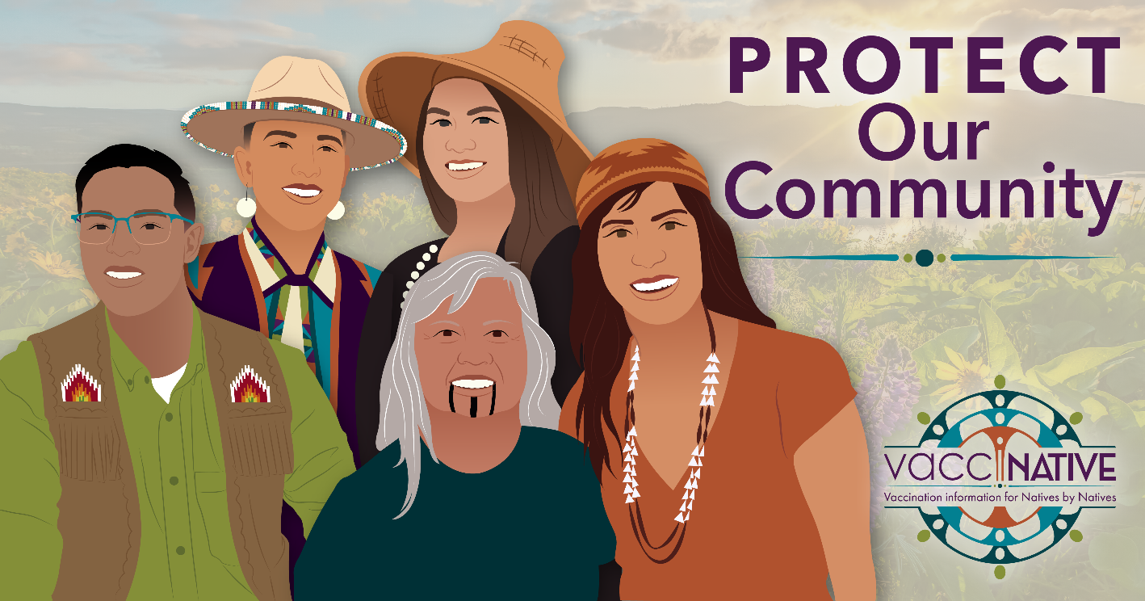
Facebook
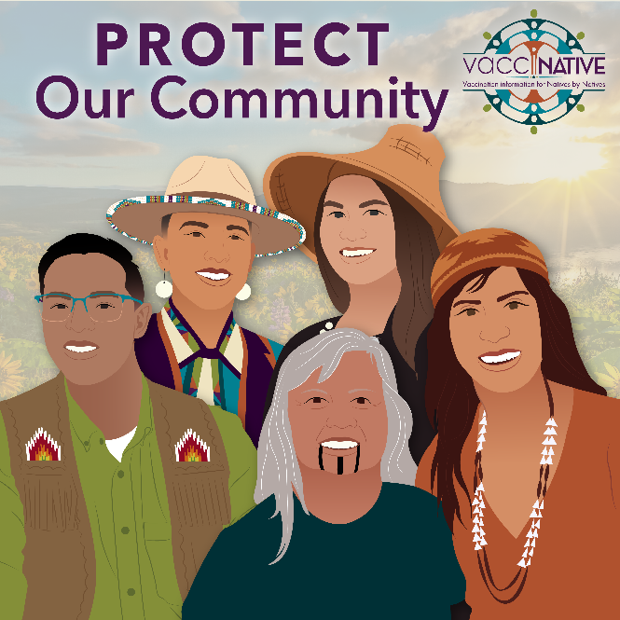
Instagram

Post 5:
Get peace of mind and help your kids soar by staying up to date on your vaccinations. For accurate vaccination info for Native people by Native people, visit: www.IndianCountryECHO.org/VacciNative

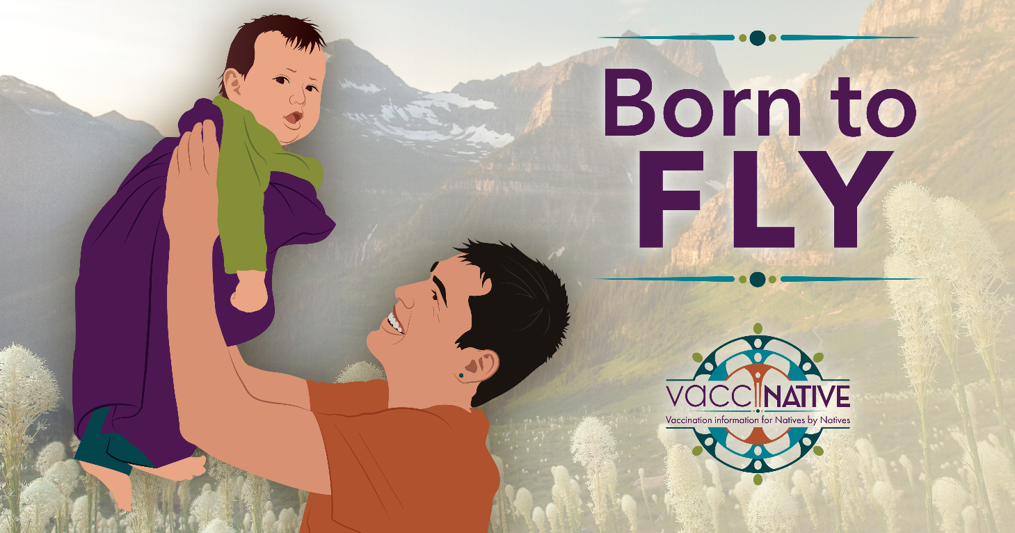
Facebook

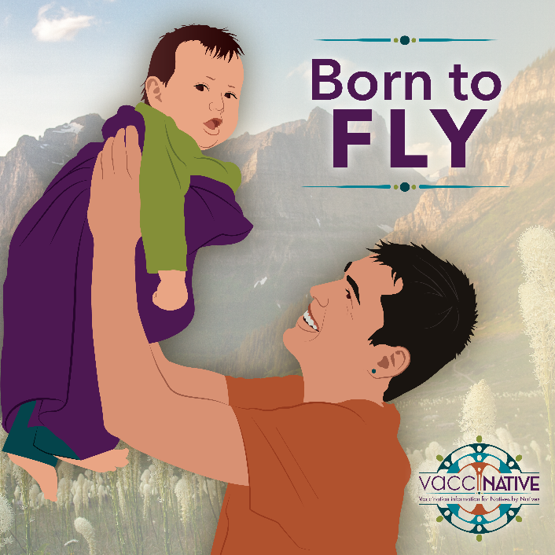
Instagram

Post 6:
Your family is always there for you. Get boosted for them. Learn more at: www.IndianCountryECHO.org/VacciNative

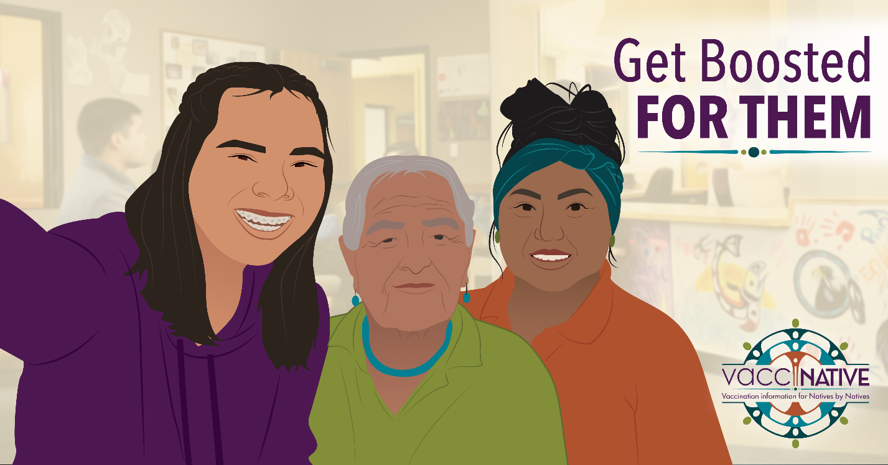
Facebook

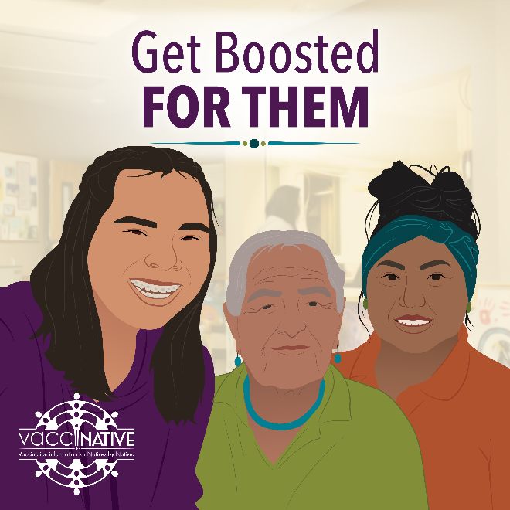
Instagram

Post 7:
Be a good relative and get boosted. For accurate vaccination information for Native people by Native people, visit: www.IndianCountryECHO.org/VacciNative

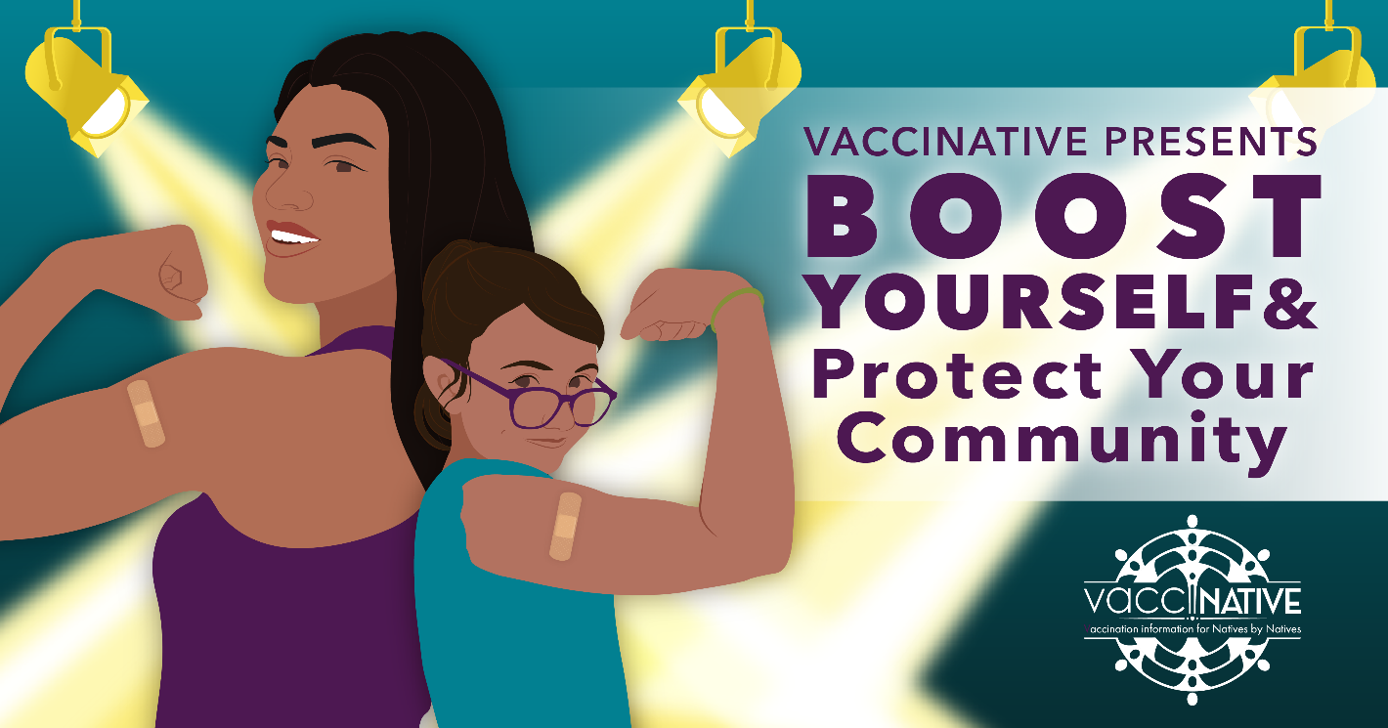
Facebook

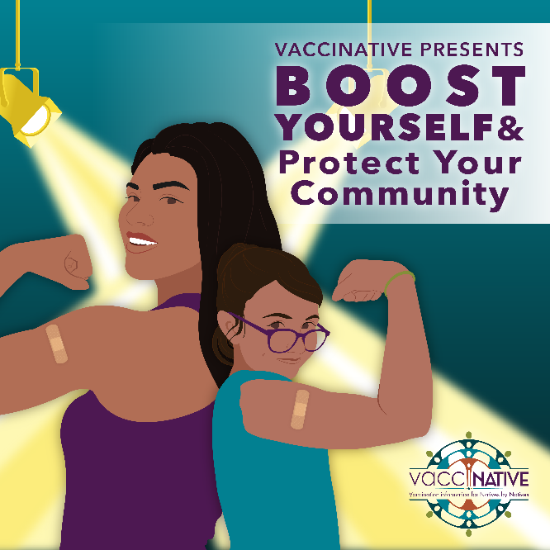
Instagram

Post 8:
Got your vaccinations?! Be a good relative and talk about vaccination with your friends and family. Learn more at: www.IndianCountryECHO.org/VacciNative

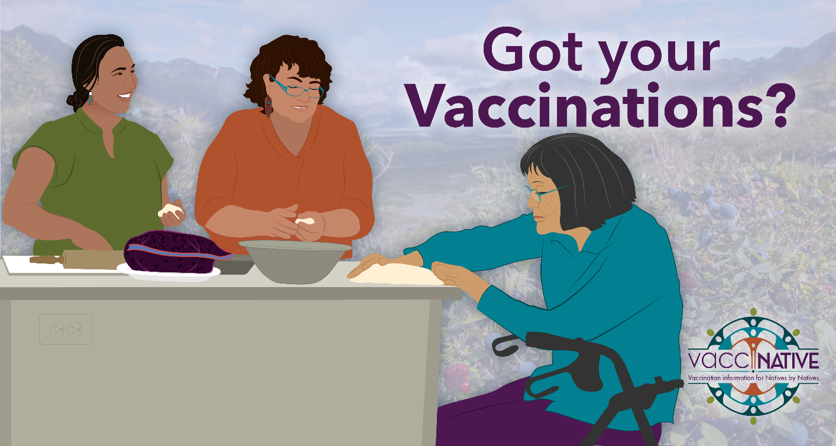
Facebook

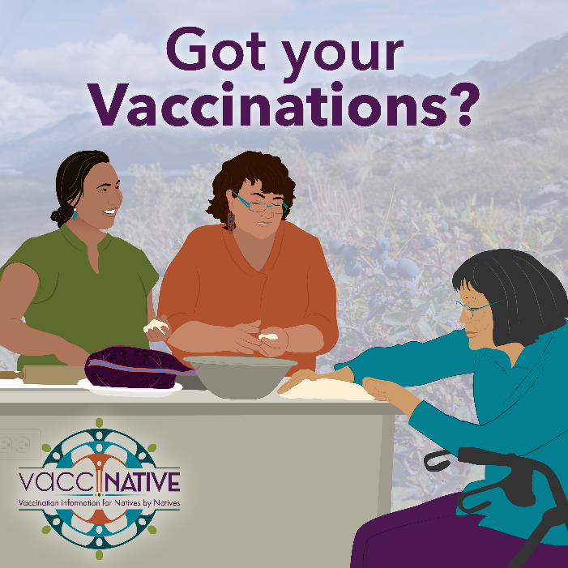
Instagram

